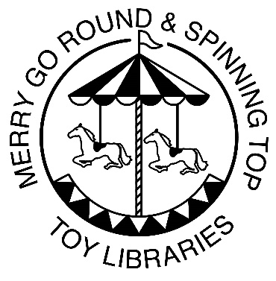
Merry Go Round Toy Libraries
Exeter Scrapstore
Gordon Road
Exeter
EX1 2DH
Tel 01392 436777
coordinator@mgrtoylibrary.org
www.mgrtoylibrary.org

Health and safety Policy
Policy statement
We believe that the health and safety of children is of paramount importance. We make the toy library a safe and healthy place for children, parents, staff and volunteers.
- We aim to make children, parents, staff and volunteers aware of health and safety issues and to minimise the hazards and risks to enable the children to thrive in a healthy and safe environment.
Insurance cover
We have public liability insurance and employers' liability insurance. The certificate for public liability insurance is displayed in each toy library.
Procedures
Awareness raising
- Our induction training for staff and volunteers includes a clear explanation of health and safety issues, so that all adults are able to adhere to our policy and procedures as they understand their shared responsibility for health and safety. The induction training covers matters of employee well-being, including safe lifting and the storage of potentially dangerous substances.
- As necessary, health and safety training is included in the annual training plans of staff, and health and safety is discussed at supervision meetings.
- We operate a no-smoking policy.
Floors and walkways
- All our floor surfaces are checked daily to ensure they are clean and not uneven, wet or damaged. Any wet spills are mopped up immediately.
- Walkways are left clear and uncluttered.
Electrical equipment
- We ensure that all electrical equipment conforms to safety requirements and is checked regularly.
- We check storage heaters daily to make sure they are not covered.
- There are sufficient sockets in our setting to prevent overloading.
- We switch electrical devices off from the plug after use.
- Lighting and ventilation is adequate in all areas of our setting, including storage areas.
Storage
- All our equipment and resources are stored or stacked safely to prevent them accidentally falling or collapsing.
Hygiene
- We have a cleaning routine for the toy library, which includes the play room and toilet
- The toilet area has a high standard of hygiene, including hand washing and drying facilities.
- We implement good hygiene practices by:
- checking and cleaning toys regularly
- cleaning and checking toilets regularly;
- wearing protective clothing - such as aprons and disposable gloves - as appropriate;
Resources and repairs
- Before purchase or loan, we check equipment and resources to ensure that they are safe for the ages and stages of the children using the toy library.
- We keep a full inventory of all items in the setting for audit and insurance purposes.
- All our equipment is regularly checked for cleanliness and safety, and any dangerous items are repaired or discarded.
- Any faulty equipment is removed from use and is repaired. If it cannot be repaired it is discarded.

Safety of adults
- We ensure that adults are provided with guidance about the safe storage, movement and lifting of large pieces of equipment.
- We provide safe equipment for adults to use when they need to reach up to store equipment or to change light bulbs.
- We ensure that all warning signs are clear and in appropriate languages.
- We record accidents on accident forms. The records are reviewed termly to identify any issues that need to be addressed.
Control of substances hazardous to health
- Our staff implement the current guidelines of the Control of Substances Hazardous to Health Regulations (COSHH).
- Hazardous substances are stored safely away from the children.
- We keep all cleaning chemicals in their original containers.
- Environmental factors are taken into account when purchasing, using and disposing of chemicals.
- All members of staff are vigilant and use chemicals safely.
- Members of staff wear protective gloves when using cleaning chemicals.
Legal framework
- Health and Safety at Work Act (1974)
- Management of Health and Safety at Work Regulations (1999)
- Electricity at Work Regulations (1989)
- Control of Substances Hazardous to Health Regulations (COSHH) (revised 2004)
- Manual Handling Operations Regulations (1992 (As Amended 2020)
- Health and Safety (Display Screen Equipment) Regulations (1992) (As Amended 2002)
Further guidance
- Health and Safety Law: What You Need to Know (HSE Revised 2009)
- Health and Safety Regulation: A Short Guide (HSE 2003)
- Electrical Safety and You: A Brief Guide (HSE 2012)
- Working with Substances Hazardous to Health: What You Need to Know About COSHH (HSE Revised 2012)
- Manual Handling at Work: A brief Guide (HSE 2020)
- This Policy was adopted by:

- The Board of Trustees at Merry Go Round Toy Libraries as documented in Committee Meeting Minutes dated 14th March 2024

- Date of Next Policy review: March 2025

